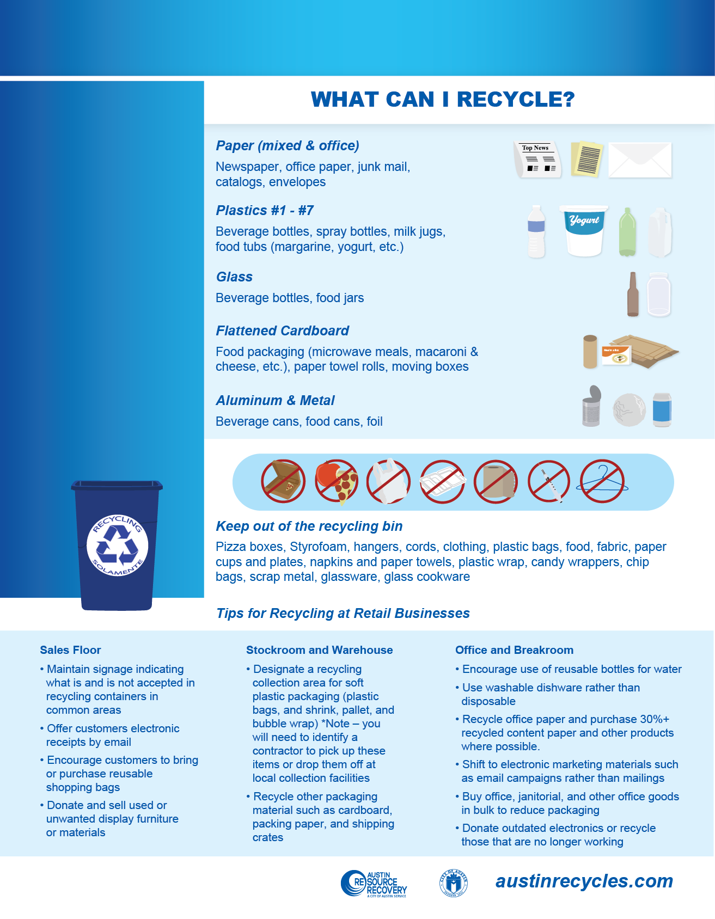z

SAMPLE

**Type your Property Name Here**

***Property specific,***

***customized text***

***goes here***

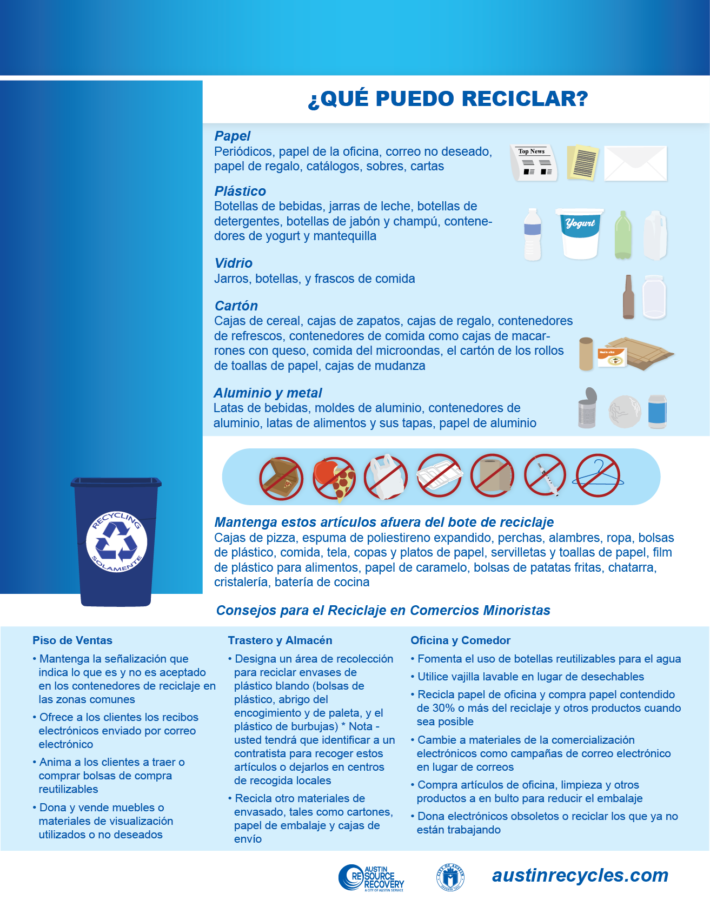

SAMPLE

**Type your Property Name Here**

***Informacion***

***sobre la***

***propiedad***

***especifica aqui***