Yellow circle indicates the desired concession vendor location.

A.B. Cantu Pan American Recreation Center
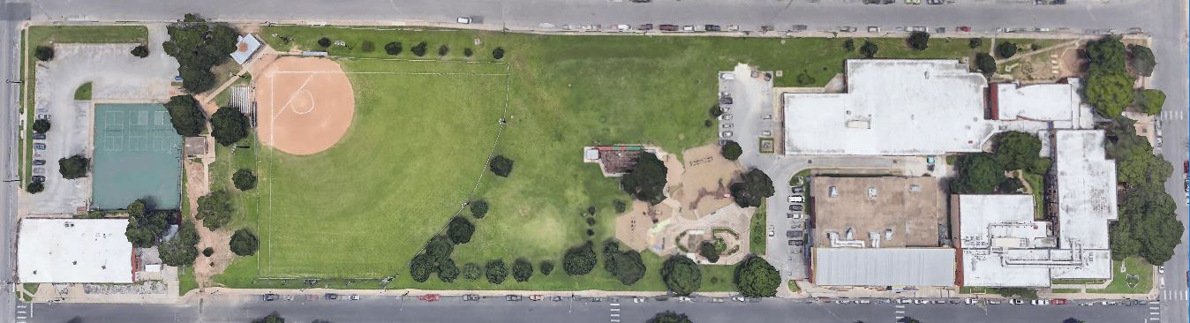

Parque Zaragoza Recreation Center
