The Culture Alive funding program will support a variety of artistic expressions and traditions practiced within diverse ALANA (African, Latino, Asian, and Native American) communities and/or cultural groups in Austin. Keeping these cultures alive is key to long-term preservation of neighborhood identity and a deep and broad artistic landscape.
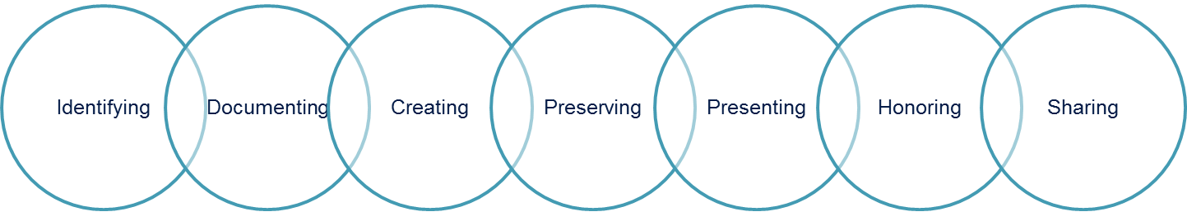
Culture Alive funding is up to $5,000 with a 25% match required (up to half of the match may be in-kind). (See Budget portion of the application.)
Monthly application submission (last Monday of the month)—January 30th is the first deadline. Applications may be emailed to laura.odegaard@austintexas.gov or dropped off to the Cultural Arts Division offices at 201 E 2nd Street, Austin, TX 78701.
Must apply 60 days prior to project start date. Activities must take place by September 30, 2017.
Projects must have a strong public access element. Types of projects may include a performance, concert, or exhibition of a particular art form; a workshop bringing together cultural specialists; an intergeneration class that culminates in a presentation; language or expression conservation or documentation of traditional art form that has a public presentation.
Eligible ALANA individual applicants must be at least 18 years old, a current Austin resident who has lived and worked in Austin as an artist for a minimum of three years and will remain a resident throughout the contract period and whose artistic practice is reflective of the cultural life of their community. Applicants may not receive any other City of Austin Cultural Arts Division funding. ALANA organizational applicants must be operating with the City of Austin or its ETJ; federal 501(c)(3)s or Texas non-profits/ informal unincorporated groups that have fiscal sponsor agreement with a federal 501(c)(3) are also eligible to apply.
Culture Alive aims to:
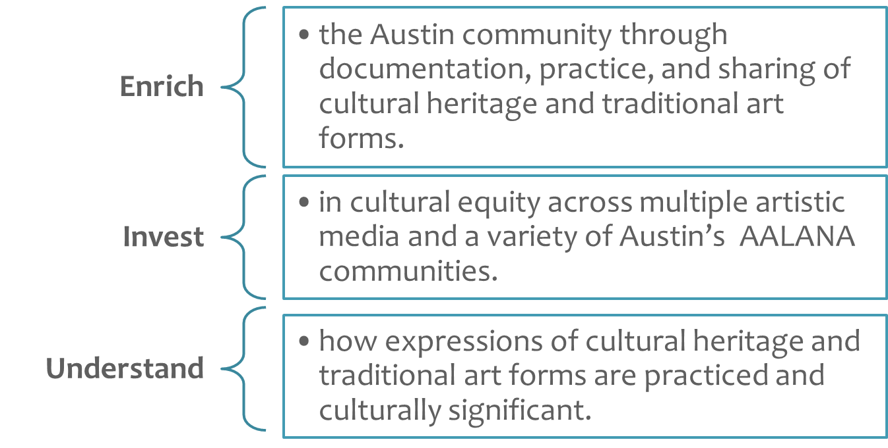
Questions about Culture Alive can be directed to laura.odegaard@austintexas.gov; 512.974.6345.

Cultural Arts Division staff will review applications based on eligibility requirements and satisfactory completion of all 4 sections of the application. Applications that meet the requirements (with a score of 37+ out of 50) will be forwarded to the Austin Arts Commission for final review and approval of funding award.
Projects must have a strong public access element and effective outreach strategy to reach its intended audience, high quality arts experience, and feasibility.
First time applicants are strongly encouraged to review the program guidelines and application, and then contact the Cultural Arts Division staff to set up a meeting prior to beginning an application: laura.odegaard@austintexas.gov; 512.974.6345.
Summary Information
Applicant Name | Sponsored Project? | Fiscal Sponsor Name
Project/Activity Title | Start Date | End Date
Have you ever received City of Austin Cultural Funding? Yes (If so, what year?______) No
Project Summary: Please describe the project for which you are requesting funds in the space provided.
Applicant(s) is/are requesting $ in Culture Alive program funding.
When:

Where:

One sentence description of project :

Applicant Information
Applicant’s Legal Name | Federal Tax I.D. | Other Common Name
Official Mailing Address |  | City | State | Zip
Telephone | District Number | Website (URL)
Fiscal Sponsor Contact/Project Director |  | Title
Address |  | City | State |  | Zip
Telephone | District Number | Email

Artistic Experience (0-15 points)
Please provide:
- Artist biography (This may be attached as a separate document).
- At least three work or portfolio samples that exemplify for artistic quality (These may be attached as a separate document). Supporting material may include: pictures, videos, excerpts of previous works or works in progress, letters of recommendation, etc.
- A short narrative (1 paragraph) addressing how the art form is rooted in and reflective of the cultural life or traditions of your ALANA community in general.

Community Impact (0-15 points)
Please provide a short narrative (3 paragraphs maximum) about the Community Impact of your project. Be sure to address the following Community Impact review criteria.
- How the art form has significance or meaning for an ALANA community in Austin specifically.
- How the project will promote a better understanding by the community at large of the cultural significance of this ALANA art form.
- How the project will enrich the Austin community through documentation, practice, and sharing of cultural heritage or traditional art forms with a strong public access element.

Project Description (0-15 points)
Please provide a short narrative (4 paragraphs maximum) about your project. Be sure to address the following Project Description review criteria.
- What is your project?
- How will it be completed? Is there a logical plan, clear and realistic assignment of roles and responsibilities, and a realistic timeline?
- What does success look like? What are the goals you hope to achieve? How will your evaluate project completion, effectiveness and progress made toward project outcomes?
- How will you promote the event to reach a wide general audience?

Project Budget (0-5 points)
Individual/Organization Name: ___________
Project Title: ___________

BUDGET – EXPENSES
Expense Description
- Project Staff/Personnel (In-Kind includes volunteers contributing time)
Description
Description
- Materials/ Supplies/ Rentals
Description
Description
- Publicity/Marketing
Description
Description
- Other (i.e. transportation, insurance, etc)
Description
Description
TOTAL EXPENSES (Cash + In-Kind = Total Expenses)
Must equal Total Income
BUDGET – INCOME
Income Source | Cash | In-Kind
- Ticket/Product Sales (how many you expect to sell e.g. 50 tickets x $15)
Description
Description
- Donations from Individuals
Description
- Donations from Businesses, Foundations, other (please list)
Description
- Other (please list)
Description
- Culture Alive Funding Request
SUBTOTALS

TOTAL INCOME (Cash + In-Kind = Total Income)
Must equal Total Expenses
By signing, I declare that the above information is true and accurate to the best of my knowledge.
___________________________________________ _______________
Signature of Applicant or Authorized Representative Date

