Austin, Texas

Business Information Form

Last Revised: January 22, 2014

Economic Development Department

“Investing in Austin’s Future”

Date Received: _____________________________

Project: ___________________________________

Instructions

THE BUSINESS INFORMATION FORM
The Business Information Form (BIF) is a foundational document in your relationship with our community. This form is designed to collect all the critical information that enables City of Austin Economic Development Department staff to evaluate the scale of your project, research the potential impact on our city, and make recommendations for incentive eligibility. Every answer influences details in the final incentive agreement, so it is imperative that this form be signed and submitted only when it is complete and ready for evaluation. While all information provided herein is intended for internal City of Austin economic development analysis, and efforts will be made to restrict circulation of the information included on the form, this document will be posted publicly to the community if an agreement is reached.

FILLING OUT THE BUSINESS INFORMATION FORM
Providing our department with a completed and signed BIF will initiate the process, but our team would like to take some time to learn more about your project and discuss our intentions behind some of the questions included in this form. Please use the contact information below to contact our division manager and set time for this brief conversation. This conversation will help to make a stronger connection between project managers and will eliminate any redundancy or confusion in the process of seeking incentives from the City of Austin. A staff member will be appointed to your project and will be responsible for answering questions, moving the applicant through our process.

NEXT STEPS
Once a complete BIF is signed and submitted, a qualifying project could receive a firm offer within 25 business days. When a company accepts an incentive offer, Economic Development staff members will prepare agreement documents and secure a date to present the proposed agreement to City Council. The project is then announced to the public one week before the Council date, and the agreement and supporting materials are posted online for public disclosure purposes. Economic Development Department staff makes a presentation to City Council, and the Council subsequently conducts a public hearing before the economic development agreement can be signed.

David Colligan

Global Business Recruitment and Expansion Manager

david.colligan@austintexas.gov

301 West 2nd Street, Suite 2030

Austin, TX 78701

(P) 512-974-6381

(F) 512-974-7825

Company Information

Company Name:

Headquarters Location: City: State:

Contact Name: First Name: Last Name:

Contact Title:

Mailing Address:
City: State: Zip:

State of Incorporation:

Phone: Fax: Mobile: Other Phone:

Email Address: Website:

The following consultant is authorized to provide and obtain information related to this application. However, the City of Austin reserves the right to contact the applicant business directly at any time.
Consultant Name ____ Phone Number

Consultant Email __________________________

Business Description:

NAICS: SIC:

Company Age:

Business Structure: Private Public Ticker Symbol

Number of Austin Locations: U.S. Locations: Global Locations:
Exact legal name of the entity applying to the City of Austin for incentives:
___________________________________________________________________________
Corporate credit rating and source Service / product produced _____________
Will the Business be required to pay state sales and use tax on equipment?
Yes No Undetermined

Minimum Requirements Checklist

The Project will locate in the Desired Development Zone (See Appendix A):

The Firm will conduct its business in compliance with environmental regulations:
The Firm will ensure that all construction workers hired for construction funded by the Firm will be provided Workers Compensation Insurance and OSHA 10 Training.
The Firm will comply with the City of Austin’s MBE/WBE Ordinance.
The Firm will ensure that all construction work funded by the Firm complies with the City’s established prevailing wage program that is used on City of Austin public works projects. Unless living wage is exempted through the exception process, the City of Austin’s living wage will apply to any prevailing wage classification that falls below the living wage. (See Appendix B for definitions)
Firm may qualify for an exception from this requirement—please complete the Exception Application if you are not able to meet this requirement.
The Firm will ensure that all workers are paid at least the City of Austin's living wage, including full-time employees, contract employees, and construction workers hired for construction work funded by the Firm. (See Appendix B for definitions)
Firm may qualify for an exception from this requirement—please complete the Exception Application if you are not able to meet this requirement.
The Firm will extend benefits to domestic partners of employees and their dependents. (See Appendix B for definitions)
Firm may qualify for an exception from this requirement—please complete the Exception Application if you are not able to meet this requirement.
The Firm will provide health insurance benefits for all new full-time employees.
Firm may qualify for an exception from this requirement—please complete the Exception Application if you are not able to meet this requirement.

Project Information

Provide a brief overview of the project including the scope of planned operations:

Is the company considering other Texas Locations? Yes No

Is the company considering other U.S. Locations? Yes No

Is the company considering other Global Locations? Yes No

Please list the other communities the company is considering (optional): ___________________________________________________________________________

Market for Product of Activity: Local State U.S. Global

Exact Location of Planned Investment in Austin (List multiple addresses if multiple properties are still under consideration):

Project Characteristics (check all that apply)

Construct New Facility Expansion from outside Austin
Lease Facility Relocation from outside Austin
Purchase New Facility Expansion within Austin
Expand Existing Facility Consolidation
Renovate Existing Facility
New Business/Start-up

Expected Start Date for Construction: Total Acres:

Investment Schedule (Please provide a 10-year list of the following items.)

Calendar Year |  | Square Footage Occupied |  | IT Equipment* |  | Machinery & Equipment* |  | FF&E* |  | Taxable  Inventory |  | Construction  Labor  (Materials & Labor) |  | Total
TOTALS
PROJECT TOTAL
*New equipment only. Do not include any replacement equipment.

Please indicate how much (if any) of the amounts listed above will be purchased within the City of Austin, and therefore subject to sales tax.

IT Equipment:_____________
M&E (Machinery & Equipment): ________
FF&E (Furniture, Fixtures, and Equipment): _________

Building Materials:_____________

If the above information is provided as a percentage of total spend, please specify what percentage of construction costs will be used for building materials:_____________________________

Will the Company be applying for Foreign Trade Zone designation? Yes No

If yes, please indicated the amount of inventory listed above would be tax-exempt:__________

Total annual company purchases subject to local sales tax: _______________
(For example: office supply purchases, operating expenses, and taxable professional services)

Depreciation Schedule (please list years for straight line depreciation)

IT: ______________ M&E___________ FF&E____________

Job Categories and Wage Distributions (When project has reached full employment)
Job Category | Number of Jobs  (employed by company) | Number of Jobs  (vendor or contract) | Average Annual Wages | Percent to be Locally Hired
Executive
Manager
Supervisor
Staff
Entry Level

Job Creation Schedule
(Please provide a 10-year list of new jobs created and wage information – EXCLUDE BENEFITS)
If the City of Austin is not selected for this project, will existing jobs leave the City?
Yes No N/A
Calendar  Year |  | Existing Jobs |  | New Jobs |  | Total Jobs |  | Average Annual Wage |  | Median Annual Wage

How many of the new jobs created require less than a college degree?_______________________

What is the expected average wage for the lowest paid 10% of local workers? _______________

Service Requirements

Project Type
Will the project involve any use other than typical office use (i.e., manufacturing, warehouse, data center)?
Yes No

If yes, please answer the questions below in full or provide a sample electricity bill as an attachment to this application.

If no, you may provide answers below or the City of Austin can provide estimates of your utility requirements for your approval based on the square footage occupied by the project.

Electric
Peak Monthly Demand in Kilowatts (KW):

Average Monthly Usage in Kilowatt Hours (kWh):

Average Monthly Load Factor:

Dual Feed Required: Yes No

Current Rate (cents per kWh):

Primary Service Secondary Service

Water
Average Monthly Usage (Kgal):

Meter Size (not required for leasing companies):

Waste Water
Average Monthly Discharge (Kgal):

Square Footage

Building Size: Manufacturing Space:

Office Space: Warehouse/Storage Space:

Data Center Space: Other Non-Office Space (specify below):
Use type:___________________________

Employee Benefits and Labor Force Practices*

Health Insurance** Life Insurance

Dental Insurance Prescription Drug Plan

Retirement Plan Vision

401(k) Flexible Spending Accounts

Paid Leave Tuition Reimbursements

Pension Disability

Counseling Other:

*If benefits are not extended to domestic partners (see Appendix B), an Exception Application form will be required.
**If health insurance benefits are not provided to all new full-time employees, an Exception Application form will be required.

Please describe training provided to employees:

Does the company provide opportunities for employee advancement: Yes No
Describe:

Are there funds for additional employee education (tuition match, etc.): Yes No
Describe:

Does the company actively promote diversity in hiring and promotion: Yes No
Describe:

Does the company provide non-discrimination policies that include both sexual orientation and gender identity in the State of Texas: Yes No
If so, please describe and attach the company policy(ies):

Does the company have either of the following: (1) Historical data that demonstrates that the company has been successful in achieving diversity in hiring through its existing programs or policies, or (2) A policy or plan for establishing goals for
diversity in hiring: Yes No
If so, please describe the historical data or policy/plan and attach the historical data or policy/plan:

Cultural/Quality of Life Considerations

Does the company have a cultural outreach program (i.e., outreach in schools, engagement with local arts groups, promotion of community diversity initiatives): Yes No
Describe:

Does the company actively encourage volunteer/charitable efforts: Yes No
Describe:

Criteria for Additional Bonus Consideration
The City of Austin provides the opportunity for a firm to qualify for additional incentives based on values established by the City Council. If you would like your project to be considered for these additional incentives, please respond to the following questions.

Will at least 10% of the new full-time jobs created by the project be filled by economically disadvantaged workers (See Appendix B)? Yes No

Is the firm willing to develop and implement a program for recruiting formerly incarcerated individuals and provide these individuals with continuing education services (either toward the attainment of a high school diploma or GED or toward the attainment of an Associate's or Bachelor's degree) or ongoing mentoring services once employed?
Yes No

Please describe or attach the Company’s policy regarding hiring formerly incarcerated individuals, including whether the company includes a question about an applicant’s criminal record in its initial job application:

Is the company willing to commit to filling at least 75% of new, full-time jobs with City of Austin residents? Yes No

Does the company intend to locate in a high frequency transit corridor, TOD, or Regional Center, Town Center, or Neighborhood Center identified in the Growth Concept Map (see Appendix A) in the Imagine Austin Plan and/or locate within ½ mile of a rail or bus stop that is accessible by safe pedestrian and bicycle routes?
Yes No

Does the company have, or would the company be willing to develop, a program to encourage employees to use alternative transportation modes through Transportation Demand Management strategies such as carpooling, flextime work schedules, and subsidizing transit costs for employees? Yes No
Describe:

Will the project qualify for a USGBC LEED Silver Certified rating or above: Yes No
Describe:

Is the Company willing to ensure that employees and/or construction workers are provided workforce development services through nonprofits that contract with the City of Austin or apprenticeship/training programs registered with the Department of Labor, or will make a monetary donation (the amount to be included in the Agreement) to a workforce training program approved by the City of Austin?
Yes No

Will the Company provide an on-site day care facility for employees that may be open to the public, and/or provide subsidized daycare for employees?
Yes No

On-Site Compliance Review Notice

In the event that a Chapter 380 Economic Development agreement is executed between the City of Austin (“City”) and a grantee, the City and an independent third party will conduct annual on-site compliance reviews and reserve the right to conduct additional on-site reviews as needed to monitor compliance.

Signature

Please provide any additional thoughts or comments related to your project that could be pertinent to the evaluation process.

To the best of my knowledge, the information included in this City of Austin Business Information Form is true and correct, as evidenced by my signature below.

Signature:
(Company Representative)

Date:

The Texas Public Information Act provides that information collected, assembled, written, produced, or maintained by the City under a law or ordinance or in connection with the transaction of official business is public information. However, the Act does provide that information relating to economic development negotiations with a business prospect is withheld from disclosure unless and until an agreement is reached. If an agreement has been reached and is ready for City Council consideration, this document will be posted to the City of Austin’s website for public disclosure.

Appendix A: Maps

Desired Development Zone Map
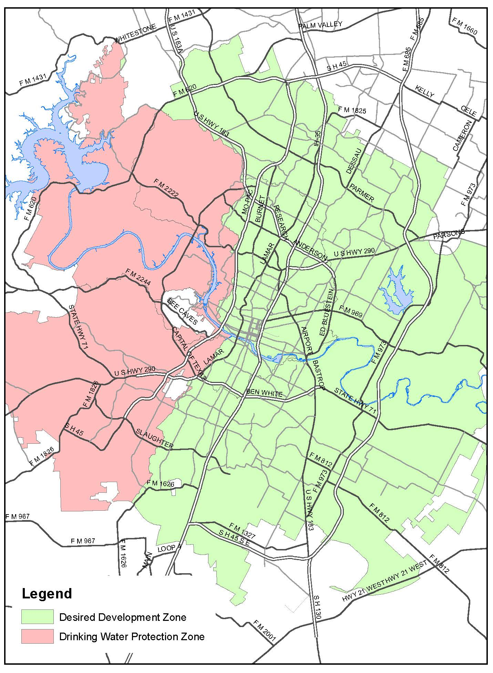

Imagine Austin Growth Concept Map
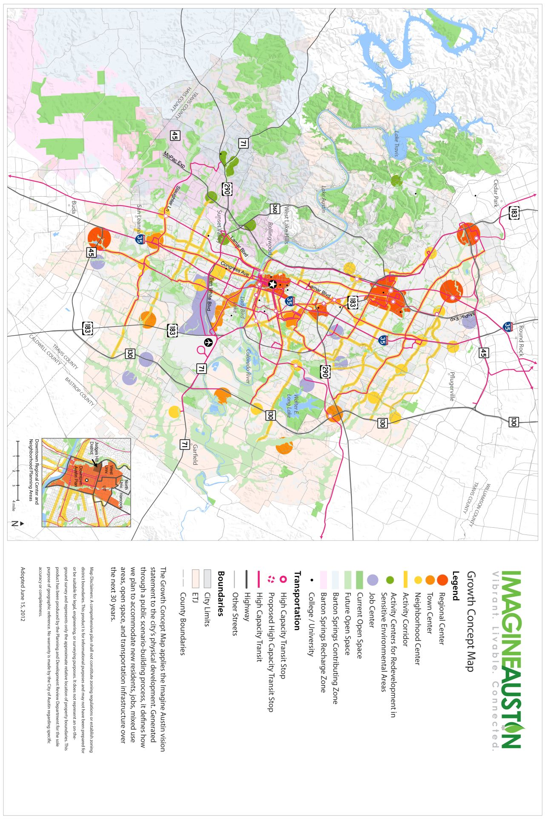
To view larger map, visit http://www.austintexas.gov/department/imagine-austin-download-center

Appendix B: Definitions

Domestic Partner

A domestic partner is defined as an individual who lives in the same household and shares the common resources of life in a close, personal, intimate relationship with an employee if under Texas law the individual would not be prevented from marrying the employee on account of age, consanguinity or prior undissolved marriage to another. A domestic partner may be of the same, or opposite, gender as the employee.

Economically Disadvantaged Worker
A person who meets one of the following descriptions:
- Is unemployed for at least three months before obtaining employment with the company;
- Has a household income of less than 80% of the area median income;
- Resides in a census tract with a rate of unemployment in excess of 150% of the Austin-MSA unemployment rate; or
- Faces or has overcome at least one of the following barriers to employment:
  - Being homeless
  - Being a custodial single parent
  - Receiving public assistance
  - Lacking a GED or high school diploma
  - Participation in a vocational English as a second language program
  - Having a criminal record or other involvement in the criminal justice system
  - Has a physical or mental disability

City of Austin Resident
Residents are defined as having a permanent address within the City of Austin and not having worked for the company prior to the effective date of the agreement.

Prevailing Wage
Prevailing wage refers to the federal and state law that requires public entities to establish certain wage rates. It applies to construction workers on contracts awarded by the public entity for public works projects and is described in chapter 2258 of the TEX. GOV’T CODE and the City has approved Ordinance No. 20030508-031, adopting the federal Davis Bacon wage rate schedule. The same prevailing wage rate schedule adopted by the City would be paid by the Company for all construction it funds unless an exception was approved.

Living Wage
Living wage refers to the concept of paying wages that are sufficient to provide the worker with housing and basic needs. The same living wage rate paid by the City (currently $11/hour) would be paid by the Company unless an exception was approved. For any construction worker classifications that have a prevailing wage rate less than the current living wage rate, the Company would be expected to be pay no less than the living wage rate for all construction it funds.

