Austin 3-1-1 Smart Phone App Fact Sheet

The Austin 3-1-1 smart phone app makes it possible for residents to create service requests with their smart phones and attach photos related to their service request. Citizens can also track the status and location of their service requests. Last year Austin 3-1-1 completed more than 200,000 service requests, but with your help, and reporting Austin 3-1-1 can respond to even more. Our goal is 1st contact resolution of any concerns in our community.
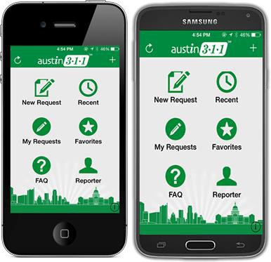

- The Austin 3-1-1 smart phone app makes it possible for residents to create service requests with their smart phones and attach photos related to their service request.

- The Austin 3-1-1 smart phone app enables real-time collaboration between citizens and their city government, 24 hours a day, 7 days a week; allowing residents to become the eyes and ears of their communities.

- The app is available on Apple iPhone and Android devices and can be downloaded for free by searching for ‘Austin 311’ in the Apple iTunes App Store and/or the Google Play Store. Users with other mobile devices can enter service requests online at 311.austintexas.gov.

- Information sent from the smart phone app goes directly to the City department responsible for responding to the issue. This saves time and reduces errors.

- Users can submit requests anonymously; however, they are encouraged to enter their contact information so City departments can contact them if they have questions.

- Photos are not required, but if possible are encouraged. Users who don’t add photos must provide a description of the issue. Austin 3-1-1 mobile app will not share photos with the public.

Main Menu Features:

- My Favorites: Allows you to receive notifications regarding the status of your request.
- Reporter: Allows you to save your information, to make future reports that much easier.
- Show on Map: Lets you see locations where requests have recently been reported.
- FAQ: Link to Frequently Asked Questions and mobile app help files.
- Recent: A list of recently submitted mobile app service requests.

Service request types available on mobile app:

- Care Facility Sanitation Concern
- Community Engagement Project Feedback
- Construction Items in ROW
- Dead Animal Collection
- Eviction/Notice to Vacate Order
- Face Covering Ordinance Violation - Business
- Fireworks Noise Complaint
- Flooding Current (Non-Emergency)
- Flooding Past
- Food Complaint
- Found Animal – Keep
- Found Dog (Confined) Pick Up
- Graffiti Removal
- Grass/Weeds Over 12" Tall
- Healthy Streets
- Homelessness in City Park
- Homelessness Matters
- Junked/Abandoned Vehicle
- Loose Dog
- Loud Commercial Music
- Other
- Park Graffiti Removal
- Park Grounds Maintenance
- Parking Violation
- Pothole Repair
- Rest Break Complaint
- School Zone Flasher – Maintenance
- Shared Micromobility
- Short-Term/Vacation Rentals
- Sidewalk Repair
- Sign – New
- Sign – Parking Maintenance
- Sign – Traffic Maintenance

- Social Distancing/Over Occupancy Concern
- Structural Conditions
- Trash/Debris on Property
- Water Waste Report
- Wildfire Prevention

