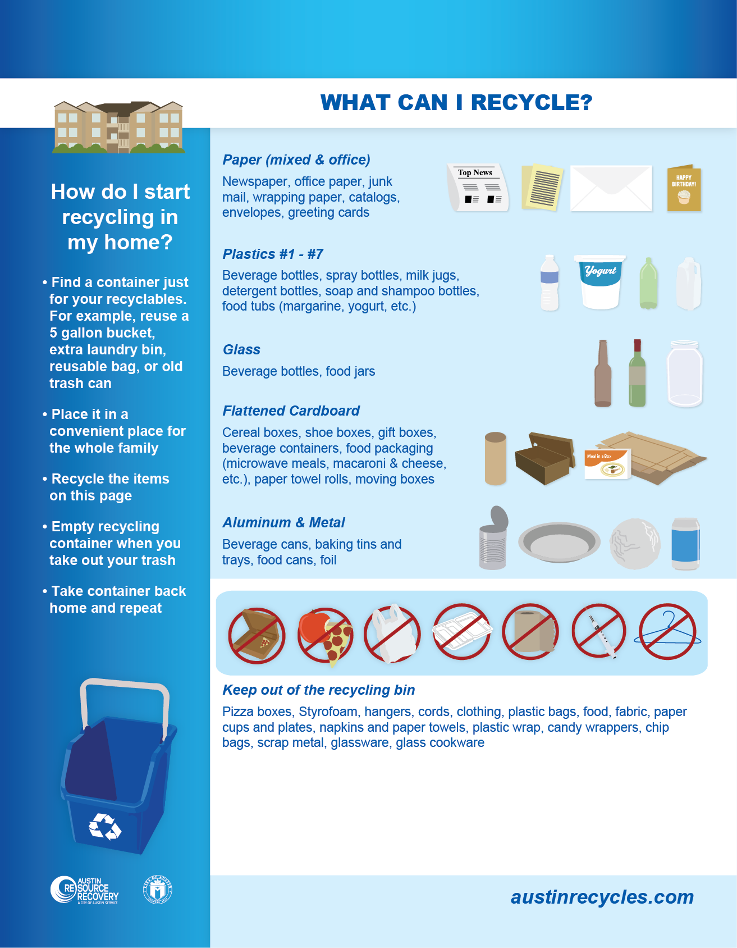

**Type your Property Name Here**

***Where do I take my recyclables?***

Insert details of where recycling containers are located on your property here.

**Please do not place food or other non-recyclable items in the recycling containers.**

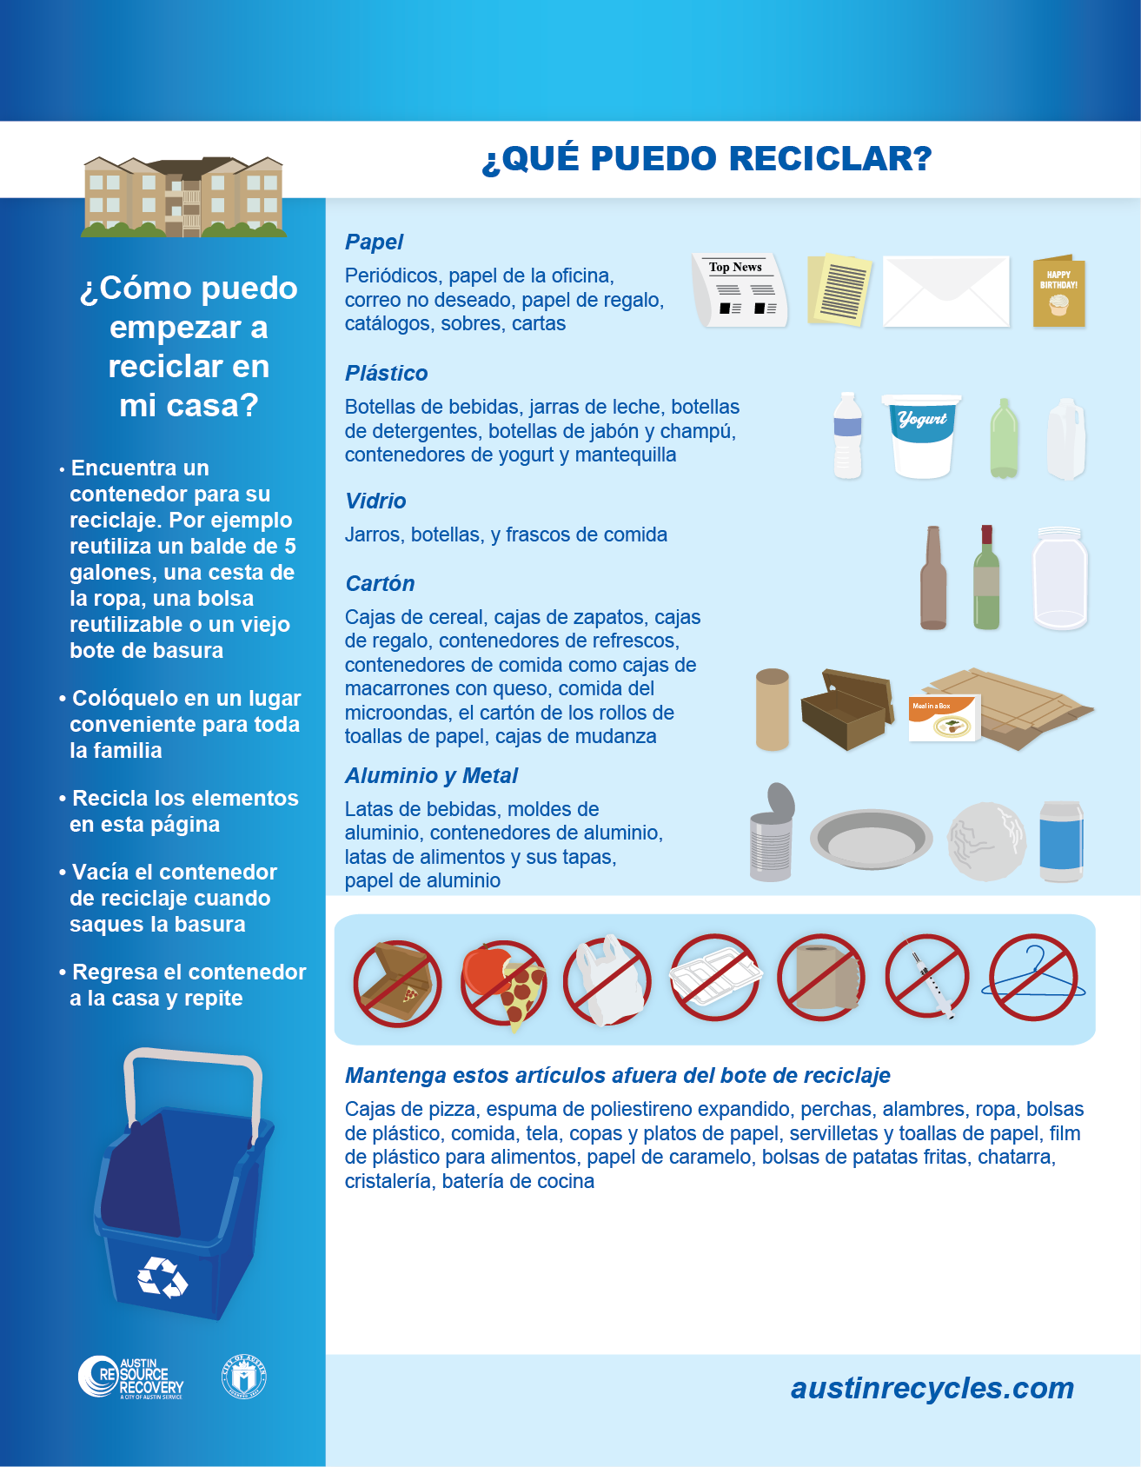

**Type your Property Name Here**

***Donde puedo llevar mi reciclaje?***

Insert details of where recycling containers are located on your property here.

**Por favor, no coloque alimentos u otros artículos que no son reciclables en los contendores de reciclaje.**