City of Austin Parks and Recreation Department
Temporary Concession Application
Commercial Use of Public Boat Ramp at Walsh Boat Landing

Commercial users may apply for a permit for use of the North Ramp and the park roads for a watercraft to enter or exit the water, provided the commercial use does not include boarding or disembarking individuals.

Acknowledgment of Receipt and Acceptance of Guidelines for Use of Walsh Boat Landing

I acknowledge that I have read, understood, and will fully comply with the Guidelines for Use of Walsh Boat Landing attached as Exhibit C to this Application.

Signed: _________________________

Printed name: ___________________

Date: ___________________________

Parks and Recreation Department (PARD) Applicant Instructions
Required Steps Prior to Temporary Concession Approval:

Step 1
Applicant Provides Detailed Application
- Read and review the full application packet.
- Complete:
  - Application Form
  - Provide an Insurance Certificate
- PARD Completeness check of Application – Approximately 5 – 10 business days

Step 2
After Application Review the Following are Submitted:
- Criminal Background Investigation
- Texas Driver License Copy (applicant)
- Health Permit Copy (if applicable)
- State of Texas Sales and Use Permit Copy
- Contract copy – licensed sanitary sewer hauler, or contract for use/services of private permitted pump-out location
  - Applicants must keep all pump-out manifests on file for inspection upon request by the City.
- Contract copy for off-site dumpster disposal service at the business address.
  - If no contract exists, written documentation on company letterhead stating litter/recycling removal location and method.
- Copy of company rules/briefing information for renters/clients
- Copy of company drop off and pick up instructions for renters/clients
- PARD may require a meeting to discuss and clarify submittals

Step 3

If Application and Supporting Documents are approved:
- Temporary Concession contract signed by Applicant and PARD
- Temporary Concession permit fees paid
- Permit released to Applicant

COORDINATOR AND COMPANY INFORMATION
Contact Name:
Company or Organization Name: |  |  |  |  |  | (the “Company”)
Are you a sole proprietor? | ☐Yes ☐No  IF “yes”, you MUST complete a sole proprietor letter on your own letterhead. Sample attached in this packet.
Business Address: |  |  |  | State: |  |  | Zip:
Mobile #: |  | Emergency #:
Email address:
Texas Driver’s License or Identification Card Number*:

NOTICE: At the time the concession is issued, a Certificate of Insurance listing the City of Austin as an additional insured and a State of Texas Sales and Use permit issued by the State Comptroller’s Office must be provided. The Comprehensive General, Auto and Marine Liability Insurance should have a combined single limit of $500,000 per occurrence. Statutory Worker’s Compensation Insurance may be necessary.
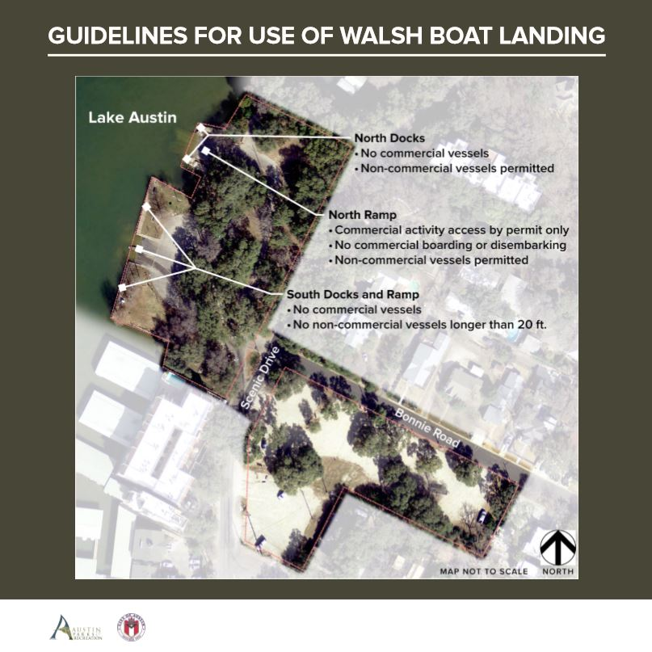
CONCESSION TYPE REQUEST (Check ONE)

Temporary Concession |  | ☐
Requested Date(s) or Six-Month Period:

PARK INFORMATION:
Park Name: | Walsh Boat Landing Park
Location in Park: | North Ramp
Commercial Use: | Use of the North Ramp and the park roads for a watercraft to enter or exit the water – no embarking and/or disembarking from vessel

DESCRIBE INTENDED USE:

ENTER REQUESTED SCHEDULE:
Day(s) requested  Business Hours  Avg. rental amount | ☐ | Mon | ☐ | Tue | ☐ | Wed | ☐ | Thu | ☐ Fri | ☐ Sat | ☐ Sun

Concession Information
List all products/services offered including price.
Will any type of food or beverage service be available?
Will alcohol be allowed through BYOB, service, or sale?
Note: | Unless for Health and Safety precautions; bulk supplies must be used versus individually packaged condiments, utensils and drinking straws, or picnic packs, such as the combined plastic wrapped fork, knife, napkin, and pepper/salt.

Sewage Disposal Location:

Pump Out Schedule:

PERMITS AND CONTRACTS:
Indicate permit number or licensed provider:
Department of Health Food Safety: | Permit number:
TABC: | Permit number:
Licensed Caterer: | Licensed Provider:
Licensed Hauler for Trash and Recycling: | Licensed Provider:
Licensed Hauler for Sanitary Pump Out: | Licensed Provider:

IMPACT MITIGATION PLANS:
Applicants must provide detailed plans to state company/concession policy and plans to ensure posted guidelines are met.
Public Parking Location | Parking at Walsh Boat Landing is not allowed for Temporary Concession Permit holders or guests.
Location for embarking and disembarking individuals | Embarking and Disembarking at Walsh Boat Landing is not allowed
Damage to Park Infrastructure | Detail the mitigation strategies to prevent damage to park infrastructure
Amplified Sound/Noise | How will the company owner and it’s representatives, contractors, or boat captains enforce sound restrictions on each vessel?
Public Safety | Detail the plans to message public safety requirements and laws to all renters
Environmental | Detail the plans for legal sewage removal and disposal from vessels
Trash and Recycling | State plan for collection, storage, removal, and off-site hauling of trash/recycling.

LIST OF WATERCRAFT / VESSEL FOR PERMITTING.

WATERCRAFT INFORMATION
Make and model of vessel:
Vessel color: |  | Length of vessel:
Texas Parks and Wildlife Registration number /expiration date:
Clean Water Certification Program marine sanitation devices (MSDs) decal number:
Insert jpg of Watercraft - Texas Registration Number must be visible

WATERCRAFT INFORMATION
Make and model of vessel:
Vessel color: |  | Length of vessel:
Texas Parks and Wildlife Registration number /expiration date:
Clean Water Certification Program marine sanitation devices (MSDs) decal number:
Insert jpg image(s) of Watercraft – Texas Registration Number must be visible

COMPLETE MORE PAGES AS NEEDED
List of Licensed Party Boat Operators by Texas Parks and Wildlife

LIST OF TEXAS PARKS AND WILDLIFE PARTY BOAT OPERATOR LICENSEES:

Party Boat Operator License is required of operators of charter vessels carrying more than six passengers and with a length exceeding 30 feet, operating on inland waters. The only exemption from this requirement is if the operator holds a USCG Operator of Uninspected Passenger Vessel (OUPV) License, often referred to as a "6-pack license," or higher level of Captain's license issued by the USCG.
Full Name:
License Number:
Expiration Date:

Full Name:
License Number:
Expiration Date:

Full Name:
License Number:
Expiration Date:

Full Name:
License Number:
Expiration Date:

Full Name:
License Number:
Expiration Date:

COMPLETE MORE PAGES AS NEEDED
Standards of Operation

Understanding that parks are a valuable resource for a large population who have diverse methods of recreation the purpose of this program is to balance the public’s ability to recreate while engaging visitors through professional instruction or experience.

As a permit holder using City of Austin parkland I will:

Business Operation:
- Clearly display identifiable business/organization name
  - signage, uniform shirt, hat, or other
- Clearly display business contact information for patron feedback.
- Clearly display all required City of Austin permits.
- Commercial Activity vessel, location, stand, vehicle, trailer, and/or push cart must be clean and in operational condition without visible damage or defects.
Public Interaction:
- Have a valid permit from the City of Austin Parks and Recreation Department and carry and/or display these credentials during business operations.
- Train employees in non-discrimination practices and standards to assure that no person be excluded from participation in, be denied the benefits of, or be otherwise subjected to discrimination on the grounds of race, color, sex, age, disability or national origin.
- Follow ADA guidelines to provide and maintain access for people with disabilities.
- Follow the rules and City ordinances at park spaces and offer courtesy to park users
- Offer courtesy to others who are recreating in the parks.
- Provide a safe and quality experience to park patrons.
- Ensure respect for public property and the property of residents and other businesses.

I understand the listed Standards of Operation and will ensure compliance. I understand that two (2) warning notifications will be given regarding the above written standards. Upon three (3) notifications the permit will be revoked.

Printed Name: __________________________________

Signature: _____________________________________

Date: _________________________________________

CONCESSION REQUIREMENTS

IF the request is approved, the Company shall comply with, and shall require its contractors, agents, invitees, guests, volunteers, and patrons to comply with all federal, state and local laws and regulations, and with all applicable City policies, rules and procedures.

IF the request is approved, the Company shall not bring or permit its contractors, agents, invitees, guests, volunteers, and patrons to bring or keep anything on City property that may adversely affect the City’s property.

Without the prior written consent of the Director of the Parks and Recreation Department (Director of PARD), the Company shall not bring or allow its contractors, agents, invitees, guests, volunteers, and patrons to bring any items onto the City’s property, or place any decorations or other items on the City’s property that may damage any portion of the City’s property, including but not limited to trees, grounds, or plant life.

The City reserves the right at any time and at its sole discretion to require the Company to remove from the City’s property any animals, furniture, fixtures, wiring, exhibits, or other items brought onto the City’s property by the Company. The Company shall immediately remove any item upon City’s request.

APPLICANT’S VERIFICATION

I verify that all of the above information is true. I have also read, understand, and am willing to comply with all federal, state and local laws and regulations, and with all applicable City policies, rules and procedures. I agree to the terms of this concession and am authorized to sign on behalf of the Concession holder.

NOTICE:

Operating outside of the approved Guidelines for use of Walsh Boat Landing park will result in the revocation of Parks and Recreation Department Permit(s)
- http://www.austintexas.gov/department/walsh-boat-landing

__________________________ __________________ _______________
Applicant Signature Printed Name Date

Exhibit A –

Key Park Code and Rules:
The following select City laws, ordinances and park rules are highlighted in this section for applicant convenience, and NOT a full representation of all federal, state, or local laws, policies, procedures, or rules.

LAWS/ORDINANCES:
- ON WATER SOUND RESTRICTIONS (link)
- WATERCRAFT AND LAKE AUSTIN. (link)
- APPROVAL TO USE PUBLIC RECREATION AREA (link)
- APPROVAL FOR COMMERCIAL ACTIVITY (link)
- WALSH BOAT LANDING GUIDELINES (attached as Exhibit C)

KEY/HIGHLIGHTED PARK RULES: (link)
  - Park curfew is 10 pm – 5 am. No activity is allowed between these hours.

Glass containers and smoking are prohibited in parks at all times.
  - Styrofoam is prohibited in all parks.
  - Additional concession, on-land presence, marketing or similar is prohibited except by additional permit.
  - All employees shall have a concession permit on site at all times.

Exhibit B – Insurance Requirements

Available online at: www.austintexas.gov/parkevents or directly here.

From the main portal, click to enter the policies and procedures section, and then scroll down to the advisory information section and select the “insurance” link.

The Comprehensive General, Auto and Watercraft Liability Insurance policy required should have a combined single limit of $500,000 per occurrence.

Statutory Worker’s Compensation Insurance may be necessary.

Please provide the full specifications document to your carrier/provider so an appropriate policy is provided.

______________________________________________________________________________

Exhibit C - Guidelines for Use of Walsh Boat Landing

Available online at: http://www.austintexas.gov/department/walsh-boat-landing
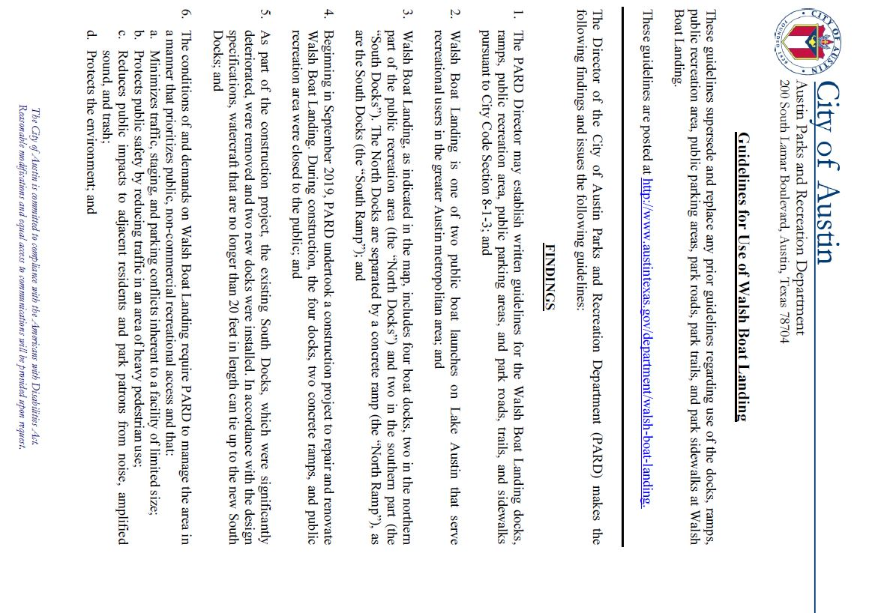
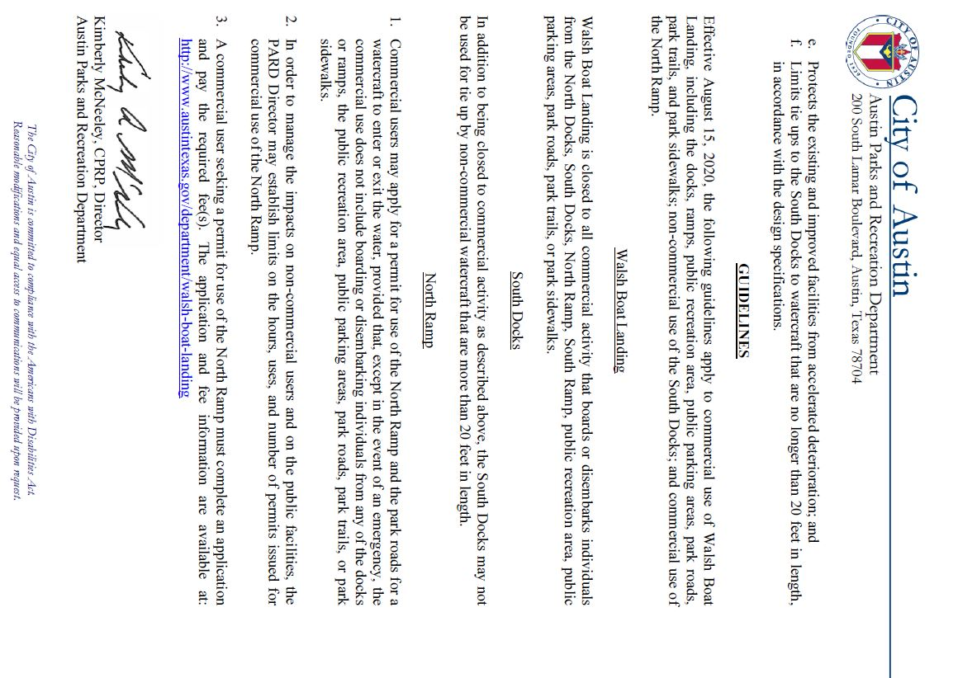

PARD USE ONLY
Parks and Recreation Department Approvals:

________________________________ __________________ _______________
Division Manager Printed Name Date
Signature

________________________________ __________________ _______________
Office of Special Events Printed Name Date
Signature

